OpenMV WiFi Shield.

Features

  - Certified WiFi module.
  - IEEE 802.11 b/g/n up to 72Mbps
  - Station mode and Soft-AP support.
  - Supports IEEE 802.11 WEP/WPA2 security.
  - Network protocols (DHCP/DNS)
  - Secure TLS stack.
  - Integrated PCB antenna.

Description

The WiFi Shield enables OpenMV cameras to connect to the Internet. It features an ATWINC1500 FCC Certified WiFi module which can transmit data at up to 72Mbps making it perfect for streaming video. OpenMV firmware has built-in support for controlling the WiFi Shield using the network module.

Device Information
PART NUMBER | BODY SIZE (NOM)
OPENMV-WIFI-SHIELD | 1.40 in × 1.05 in

Applications

- MJPEG Streaming.

- Wireless programming.

.
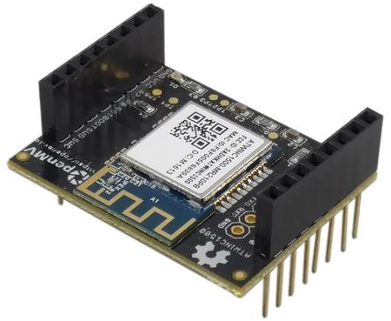

Table of Contents
1 Features 1
2 Description 1
3 Applications 1
4 Pin Configurations and Functions 3
5 Electrical Characteristics 4
5.1 Recommended Operating Conditions 4
6 Mechanical Information 5

Pin Configurations and Functions

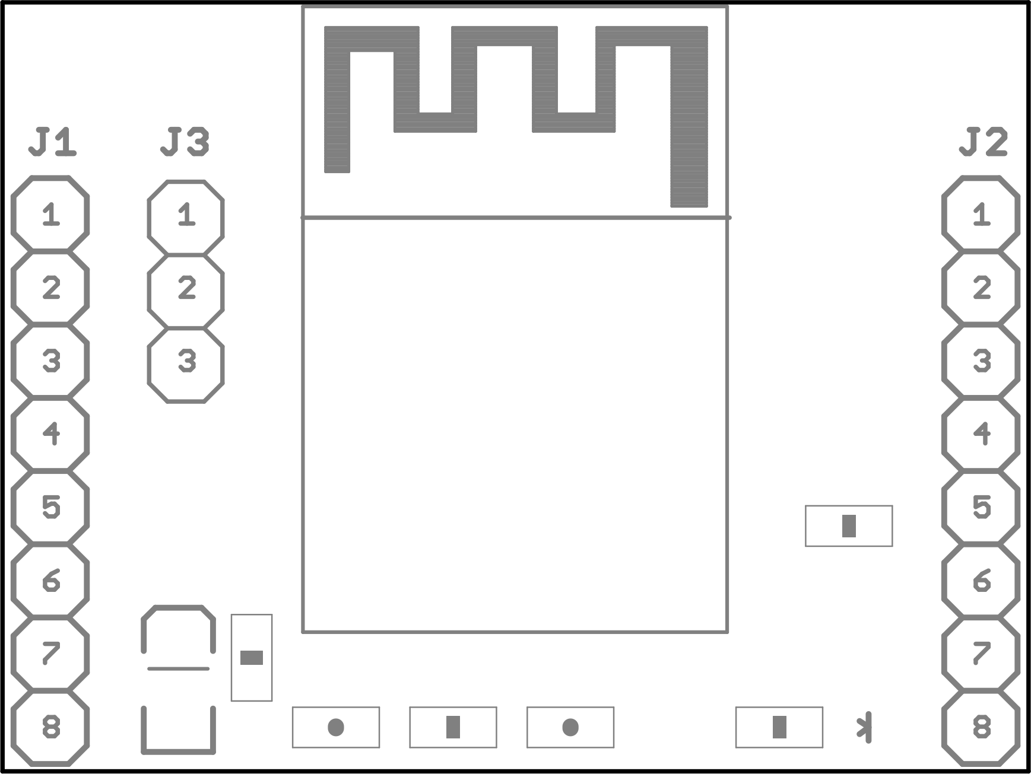

Pin Functions
Pin |  |  | Description
Header | No | Name | Description
J1 Pin Configuration
J1 | 1 | P0 | SPI MOSI
J1 | 2 | P1 | SPI MISO
J1 | 3 | P2 | SPI SCLK
J1 | 4 | P3 | SPI SS
J1 | 5 | P4 | NC
J1 | 6 | P5 | NC
J1 | 7 | P6 | Chip Enable
J1 | 8 | 3.3 | 3.3v input
J2 Pin Configuration
J2 | 1 | RST | NC
J2 | 2 | BOOT | NC
J2 | 3 | SYN | NC
J2 | 4 | P9 | NC
J2 | 5 | P8 | IRQ
J2 | 6 | P7 | RESET
J2 | 7 | VIN | NC
J2 | 8 | GND | GND
J3 Pin Configuration
J3 | 1 | GND | GND
J3 | 2 | RXD | Debug UART RX
J3 | 3 | TXD | Debug UART TX

Electrical Characteristics

5.1 Recommended Operating Conditions

SYMBOL | RATINGS | MIN | MAX |  | UNIT
V_{IN} | External input supply voltage range. | 3.0 | 3.6 |  | V
I_{OUT} | External output supply current range. |  |  | 500 | mA
T | Operating Temperature | -40 | 85 |  | °C

Mechanical Information
The following information is the most current data available for the designated device. This data is subject to change without notice and without revision of this document.

